Development of Web Based User Tracking System

Submitted by

Mushahedur Rahman Khan

1834902513

A project report submitted in partial fulfillment of the requirements for the degree of

Bachelor of Science in Computer Science and Engineering from City University



DEPARTMENT OF COMPUTER SCIENCE AND ENGINEERING

CITY UNIVERSITY DHAKA, BANGLADESH

NOVEMBER 2022

Development of Web Based User Tracking System

Submitted by

Mushahedur Rahman Khan

1834902513

A project report submitted in partial fulfillment of the requirements for the degree of

Bachelor of Science in Computer Science and Engineering from City University



DEPARTMENT OF COMPUTER SCIENCE AND ENGINEERING

CITY UNIVERSITY DHAKA, BANGLADESH

NOVEMBER 2022

Development of Web Based User Tracking System

Submitted by

Mushahedur Rahman Khan

1834902513

Supervised by

Md. Ataullah Bhuiyan

Senior Lecturer, Department of CSE

City University

A project report submitted in partial fulfillment of the requirements for the degree of

Bachelor of Science in Computer Science and Engineering from City University



DEPARTMENT OF COMPUTER SCIENCE AND ENGINEERING

CITY UNIVERSITY DHAKA, BANGLADESH

NOVEMBER 2022

DECLARATION

This is to certify that the project titled” **Development of Web Based User Tracking System.**” is the result of our study in partial fulfillment of the B.Sc. Engineering degree under the supervisor of Md. Ataullah Bhuiyan, Senior Lecturer, Department of Computer Science and Engineering (CSE), City University, Bangladesh. It is also hereby declared that this project or any part of it has not been submitted elsewhere for the award of any degree.

SIGNATURE OF AUTHORS SIGNATURE OF SUPERVISOR

|  |  |
| --- | --- |
| —————————————-  MUSHAHEDUR RAHMAN KHAN  ID: 1834902513  Department of Computer Science &  Engineering.  City University, Dhaka, Bangladesh. | —————————————-  MD. ATAULLAH BHUIYAN  Senior Lecturer,  Department of Computer Science &  Engineering.  City University, Dhaka, Bangladesh. |

i

ACKNOWLEDGEMENT

First, I would like to say heartiest thanks to almighty “ALLAH” for giving us the strength to finish the project as a part of our partial fulfillment for the requirements for the Degree of B. Sc. in Computer Science and Engineering. We express our profound gratitude and deep regard to our supervisor Md. Ataullah Bhuiyan, Senior Lecturer Co-Ordinator, Department of Computer Science and Engineering (CSE), City University, Bangladesh. for his guidance, valuable feedback, and constant encouragement support, utmost patience and trust with respect throughout this project. His valuable suggestions were of immense help. We would like to say Special thanks to our head of the department Md. Safaet Hossain, Department of Computer Science Engineering of City University for his precious advises, fruitful suggestions and coordination. We would like to express our heartiest gratitude to Prof. Dr. Engr. Mohammad Humaun Kabir, Dean,Faculty of Computer Science Engineering, City University for allowing us to do the projects. Also we want to extend a sincere and heartfelt obligation towards all the faculties of the Department of Computer Science Engineering of City University, Bangladesh for giving us the opportunity to complete the work and necessary support during the period, This project work would not have been possible without the encouragement, logical help and advice from our friends. We are grateful to them. Finally, we must acknowledge with due respect the constant support and patience of our parents. At last, we are also grateful to the City University, Bangladesh, for allowing me to do this project and providing all the required facilities.

ii

**ABSTRACT**

In the present time, every website user wants to stay one step ahead of his rival sites. Moreover, I would like to know the current idea of the website's position after the next five to ten years. Our point of view, modern innovation Web analysis tools, and user tracking systems can monitor a website using all the time. A scripting code will be generated from our system if you provide us with the link to his website after signing up in our system. If you update the website index by keeping the header of the tag, a dashboard will be created for the website user of our system. A dashboard will be created for that. From there you will see the live request handling counter. There are some web applications though, that can't really provide everything together so nicely. All in all, our system will definitely help you stay ahead in today's competitive era. We will build our system with the latest technology.

iii

**Table of Contents**

CHAPTER 1 Intruduction 1

1.1 Introduction 1

1.2 Problem Statement 2

1.3 Objective 3

1.4 Features 3

1.5 Budget 4

1.6 Business Goal 4

CHAPTER 2 Background And Related Studies 5

2.1 Theoretical Background 5

2.2 Compare with Existing Work 7

2.3 Target User 7

CHAPTER 3 Methodology 8

3.1 Structure of a Life Cycle 8

3.2 Working strategy 8

3.3 Team Work 9

3.4 Gantt Chart 10

3.5 Principles of System Analysis 10

3.6 The System Design 11

3.6.1 The Use Case Diagram 11

3.6.2 The Database Diagram 12

3.6.3 The Activity Diagram 13

3.6.4 The E-R Diagram 14

3.6.5 The Class Diagram 15

3.7 Software & Hardware used in the project 16

3.7.1 Technology used 16

3.7.2 Software Used 16

3.8 Overview of programming instruction 17

CHAPTER 4 Results And Discussion 18

4.1 Testing Implementation 18

4.2 Questions for some users: 19

4.3 Implemented Result 20

4.3.1 Web Analyze Result 20

4.3.2 Keyword Analyze Result 30

4.3.3 Meta Tag Generator 34

4.4 Discussion 38

CHAPTER 5 Conclusion 39

5.1 Conclusion 39

5.2 Scope of Improvement 39

REFERENCES 40

LIST OF FIGURES

|  |  |  |
| --- | --- | --- |
| **Figure No Figure Contain** | | **Page No** |
|  |  |  |
| Fig. 1.1 | Statistic of Global Growth of E-commerce sites. | 4 |
| Fig. 1.5 | Budget Details. | 7 |
| Fig: 2.2 | Compare with Existing Work. | 8 |
| Fig. 3.1 | Structure of a Life Cycle | 9 |
| Fig. 3.3 | Team Work | 10 |
| Fig. 3.4 | Gantt Chart | 11 |
| Fig:3.6.1 | Use Case Diagram | 12 |
| Fig:3.6.2 | Database Diagram | 13 |
| Fig:3.6.3 | Activity Diagram | 14 |
| Fig:3.6.4 | E-R Diagram | 15 |
| Fig:3.6.5 | Class Diagram | 18 |
| Fig: 4.1 | Implement two features | 19 |
| Fig:4.1.1 | Signup and Login. | 19 |
| Fig: 4.1.2 | Dashboard | 20 |
| Fig. 4.1.3 | Types of Visitors and Add a new site. | 20 |
| Fig: 4.1.4 | Add a new Site | 21 |
| Fig: 4.1.5 | Generate tracking scripts | 21 |
| Fig: 4.1.6 | Site Details | 22 |
| Fig: 4.1.7 | Type of Page Visitor | 22 |
| Fig: 4.1.8 | Live Request Handling Counter Statistics | 23 |
| Fig: 4.1.9 | Devices and OS Statistics. | 23 |
| Fig: 4.1.10 | Top Visitors by Country. | 24 |
| Fig: 4.1.11 | Country base Total visitor. | 24 |
| Fig: 4.1.12 | Kind of Devices. | 25 |
| Fig: 4.1.13 | Type of Browser. | 25 |
| Fig: 4.1.14 | Type of Operating System. | 26 |
| Fig: 4.1.15 | Type of Search Engines. | 26 |
| Fig: 4.1.16 | Country Detected. | 27 |
| Fig: 4.1.17 | Visitor IP Position 1. | 27 |
| Fig: 4.1.18 | Visitor IP Position 2. | 28 |
| Fig: 4.1.19 | User menu. | 29 |
| Fig:4.2.1 | Keyword Generator | 30 |
| Fig:4.2.2 | Organic Keyword | 31 |
| Fig:4.2.3 | Related Keywords | 32 |
| Fig:4.2.4 | Related Keywords and Description. | 33 |
| Fig:4.3.1 | Meta Tag Generator1 | 34 |
| Fig:4.3.2 | Meta Tag Generator2 | 34 |
| Fig:4.3.3 | Meta Tag Result | 35 |
| Fig:4.3.4 | Keyword Generator | 35 |

# CHAPTER 1

INTRODUCTION

## 1.1 Introduction

How awkward is the own website while keeping up with the current technology, how user effective is it in any sector? It is very important to know them. This shows us every social, economic, and business institution a face of successful assurance. If we look at the statistics. There are over **600 million** blogs in the world today, out of over **1.9 billion** websites.[2]

**How Many eCommerce Sites Are There?** There are more than **26 million** eCommerce sites across the entire globe, with more and more being created every single day.[1]

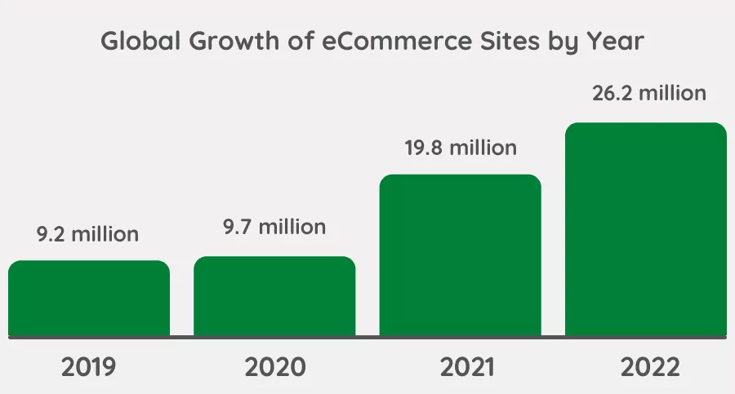

Fig:1.1 Statistic of Global Growth of E-commerce sites

Web analytics generally refers to the measurement of website data for the purpose of understanding the usage patterns of a website, which typically includes - web usage and patterns, user-supplied data, transactions, site performance, website usability, etc. Analytics helps organizations or individuals to track the performance and usability of their website and also learn about the users of the website such as who they are, where they are accessing from, and how they are using the website, etc. Analyzing the data collected can help companies improve their websites.

Among the features of our website analytics system, when a user registers with us here and then gives us the URL of his website, we will generate a code on his entire site based on the address of that URL. If you update your site's index tag, it will be activated in our system, where the user can see the complete overview of the website. A dashboard will be created for that. From there you will see the live request handling counter. You will be able to know how many requests have been made, through which you will understand how many people are interested in which pages. A good idea can be taken very easily by looking at such a statistic. You can directly see a statistic where users are visiting the website with any device. Such as desktop, laptop, tab, mobile phone, what percentage of visitors are using any device? The sites being visited using any browser on these devices can be tracked.

It will be known what the demand for any product is in any country. It is possible to know precisely from our system how many visitors have visited the webpage or website according to that location. A product that will be very useful in selling will help every trader to build a time efficient from the confusing information of many. Moreover, you will get an accurate idea of how much time it will take to load a page. As a result, search engine optimization will help a lot to work on it and make every website fast.

If you would like to see that you can find the right competitor for this competition and take action accordingly if you want, we can give him good advice on how to improve his site.

## 1.2 Problem Statement

After many days, when I met an uncle, I knew and asked a lot about me. I saw that he was very worried. When asked, he said that he has been running a company for a long time where they have been providing network and internet services to big companies. Some days a rival company is doing better than them. So, I said that there are some websites online that can benefit you by giving you a lot of information about the links on the website you run. He said he was actually doing this by linking to some websites. Actually, it is not possible to make time together. It's very cumbersome and their analytics don't seem accurate to me.

Then I started looking but what are the websites that provide this service? Even after searching a lot, a good website together with your name where all the benefits can be found together. How many of them do I get like Hotjar has no age testing, generates a keyword, and so on, but from what I saw, fully monetization facility informative information was not found together anywhere. There are many errors they have.

To solve that problem, we are developing a web analytics tool and user tracking system combining all the features.

## 1.3 Objective

Every website user can see the feedback on his site. From there they can check the validity of their site. For how many clients are visiting from which country? You can see the percentage of Male females. Even if you want you can get good guidelines from our system which will keep website users a few steps ahead.

* To help customize all types of websites including e-commerce websites in the right way.
* To help ensure entrepreneurs with accurate information.
* Every website user can find and improve their website errors.

## 1.4 Features

1. Register with Google or GitHub.
2. Traffic and Engagement
3. Geography & Country Tracking
4. Audience Demographics
5. Generate Keywords
6. Meta Tag Generator.
7. Authorization and Authentication.

## 1.5 Budget

|  |  |
| --- | --- |
| **Title** | **Amount For BDT** |
| Background Study and Requirements Analysis | 50000 |
| UI / UX Designing | 45000 |
| Frontend Development | 115000 |
| Backend Development | 140000 |
| API Development | 45000 |
| Deploy and Maintenance | 35000 |
| 1 Year Services | 120000 |
|  |  |
| **Total =** | **6,00000** |

Fig: 1.5 Budget Details

## 1.6 Business Goal

This project is a very profitable business. As many websites are being created every day, everyone wants to monitor the site on their own responsibility. When they can do this easily through our system, they will not go anywhere else. That's why we will initially give it free for seven days. By which they will become more accustomed to using our system and then never go anywhere else. After seven days of usage when we will be charged a subscription charge every month then our profit will start coming.

# CHAPTER 2

BACKGROUND AND RELATED STUDIES

## 2.1 Theoretical Background

1. **Hotjar:** We use a select number of trusted third-party service providers for certain technical data analysis, processing and/or storage offerings (IT and related services). These Third-Party service providers are selected and meet high data protection and security standards. We only share Data with them that is required for the services offered and we bind them to keep any information we share with them as confidential and to process Personal Data only according to our instructions [6].
2. **Similarweb:** We will ask you to provide personal information if you choose to create a similar web account or use our services. This may include your name, personal and work email, work or address, employer, payment information, and contact number. We collect the information, only if voluntarily provided by you, in order to create and authenticate your account and you access to our products and services. Where you try to consult with a member of our sales team, we will also collect personal information that you voluntarily provide about your work and your company [7].
3. **Semrush:** Our marketplace features select apps that cover the range of your marketing needs from video tracking on YouTube to creating compelling banners for social media. We handpick each solution to make sure you get the top apps, providing you with the Semrush customer support and taking care of everything from billing to the sign-up process [8].
4. **Chartbeat:** Chart beat intelligence platform for publishers, media companies to build audiences with real-time and historical editorial analytics across desktop, social, and mobile platforms. Chart beat helps digital publishing organizations understand what, within their content is people engaged. Partnering with more than 60,000 media brands across 60 or more countries, Chart beat’s historical dashboard, in-depth headline testing and optimization tools, robust reporting, and more help the world’s leading media organizations understand, measure, and business value from the earned by their written and video content [9].
5. **Ahrefs:** Ahrefs' founder and CEO, Dmitry Gerasimenko, built his first document search engine when he was only 15. His interest in search engines never waned and in 2007, he revisited his work on search engines for documents and files. This led to the birth of our backlinks index in 2010, which in turn became the source of data for Ahrefs' first version of Site Explorer. When launched, Site Explorer disrupted the stagnant field of backlink analysis and kick-started a new round of competition among SEO tool providers. It quickly became one of the world's best backlink analysis tools. From our humble beginnings, Ahrefs has steadily grown. Today, we update our index with the freshest backlinks on the web every 15 minutes, and our crawler processes up to 8 billion pages a day. That's more than a third of what Google bot does! [10].
6. **Statcounter**: We have the utmost respect for your privacy and the privacy of your website visitors. When a person visits a page on your site that includes the Statcounter code, only their anonymous data is processed and analysed by Statcounter and stored on our servers. See our Privacy Policy for more details. We ensure the Statcounter does not slow down your website by investing heavily in the latest server technology and consistently monitoring performance [11].
7. **Openwebanalytics**: Open Web Analytics (OWA) is an opensource web analytics software framework that you can use to track and analyze how people use your websites and applications. OWA is licensed under GPLv2 and provides developers with easy ways to add web analytics to their sites using simple Javascript and PHP based APIs. OWA also comes with support for tracking websites made with popular content management frameworks such as WordPress and Media Wiki [12].
8. **Google Analysis:** Google ads give you control over your advertising budget. Set a monthly budget cap, and never go over it. Plus, you can pause or adjust you spend any time. [13].

## 2.2 Compare with Existing Work

|  |  |  |  |  |  |  |  |
| --- | --- | --- | --- | --- | --- | --- | --- |
| **Existing**  **Project** | **Project Features** | | | | | | |
|  | **Device**  **Targeting** | **Geography & Country Targeting** | **City**  **Targeting** | **User**  **Activity** | **Traffic and Engagement** | **Site Speed**  **Report** | **Generate**  **Keywords** |
| **Hotjar** | Yes | yes | yes | Yes | No | No | No |
| **Similarweb** | yes | yes | yes | Yes | Yes | yes | No |
| **Semrush** | No | yes | yes | Yes | Yes | yes | yes |
| **Chartbeat** | yes | yes | yes | Yes | Yes | No | No |
| **Ahrefs** | No | yes | No | No | Yes | yes | yes |
| **Statcounter** | Yes | yes | yes | Yes | No | No | No |
| **Openwebanalytic** | No | yes | yes | Yes | Yes | No | yes |

Fig: 2.2 Compare with Existing Work

## 2.3 Target User

* Personal team working.
* Single or multiple companies (Startup to Middle East).

# CHAPTER 3

METHODOLOGY

## Structure of a Life Cycle

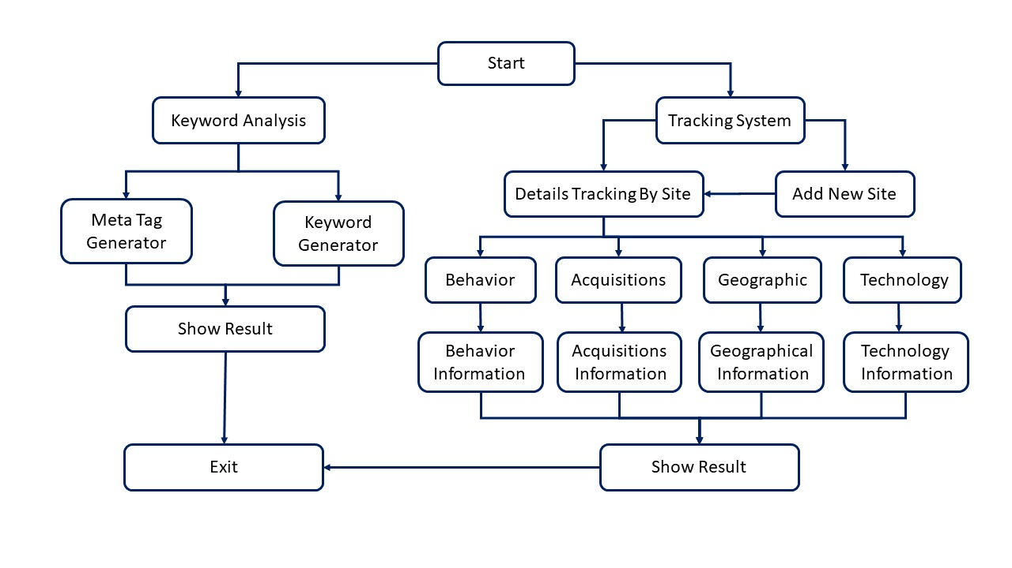

Fig: 3.1 Structure of a Life Cycle

## Working strategy

In our project, we have divided the tasks into several parts, so that it becomes much easier to do our tasks. And we know that a big job is easier to do when broken down into parts. The parts are web analytics tool, keyword analysis and meta tags generator. Let's start with web analytics and user tracking tools. Users have to create an account here. After the account is created, they will add their website, the website that wants to do the trekking will add the website. When adding websites, they will be given a script code, which will be different for each site. And the code should be placed in the main file of the website in the head tag or body tag. Then the user has no action. After coming to the site and logging in, clicking on the site, it will go to the dashboard of the site. And get all the necessary information that we have provided. For example, from where the visitor of the user's site is visiting, which area, which browser, which operating system, is coming through any reference. He can see all these information.

Now let's come to the generator of the meta tag, here the user will generate some meta tag just by giving his required information. Note: All the information here should be already available to the user.

Finally, keyword analysis, here the user finds a keyword like his product by analyzing several data of Google and several results will be displayed in front of the user. Here basically based on the keyword given by the user, some organic results related to that keyword, some questions and answers, and some related queries data will be given as results. Along with all this, the related description of the analyzed keyword will be provided, so that the user can easily get a short description of the keyword of his choice.

## Team Work

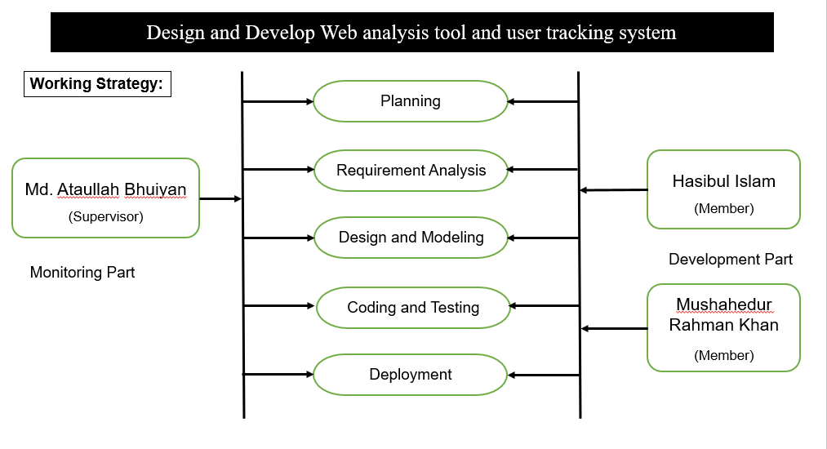

Fig: 3.3 Team Work

## Gantt Chart

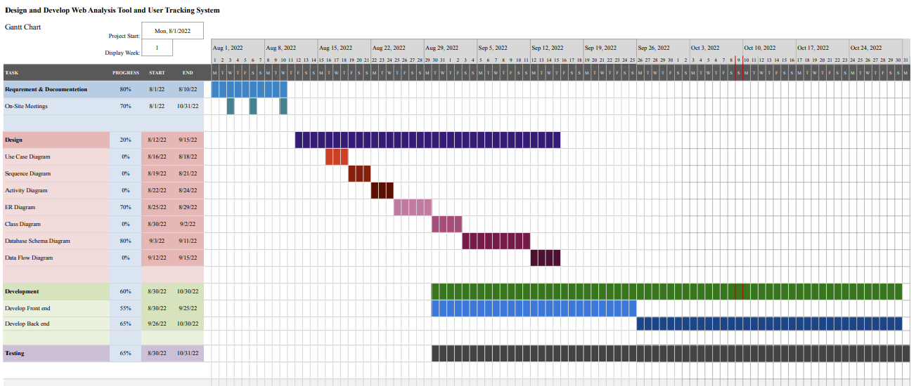

Fig: 3.4 Gantt Chart

## Principles of System Analysis

Analyzing systems quantitatively allows developers to select and/or update the most efficient architecture and generate engineering data. Each time technical choices or decisions are made, compliance with system requirements must be assessed.

Technical decision-making is made rigorously through systems analysis. An analysis of trade-offs is conducted using modeling and simulation, cost analysis, technical risk analysis, and feasibility analysis.

## The System Design

### 3.6.1 The Use Case Diagram

Fig:3.6.1 Use Case Diagram

### 3.6.2 The Database Diagram

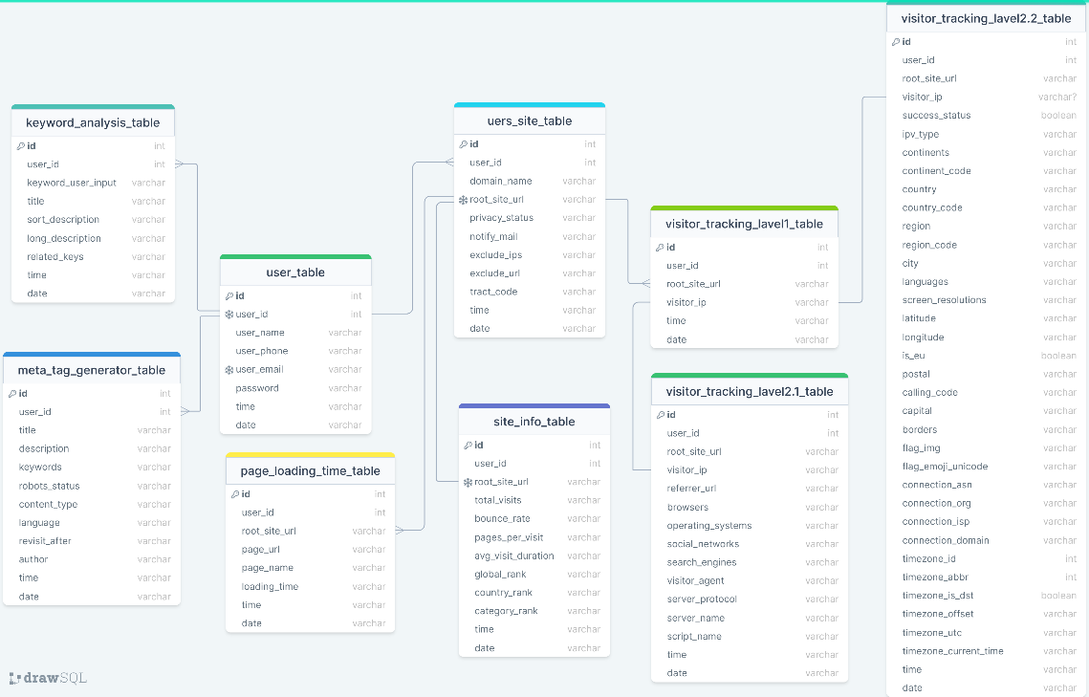

Fig:3.6.2 Database Diagram

### 3.6.3 The Activity Diagram

Fig:3.6.3 Activity Diagram

### 3.6.4 The E-R Diagram

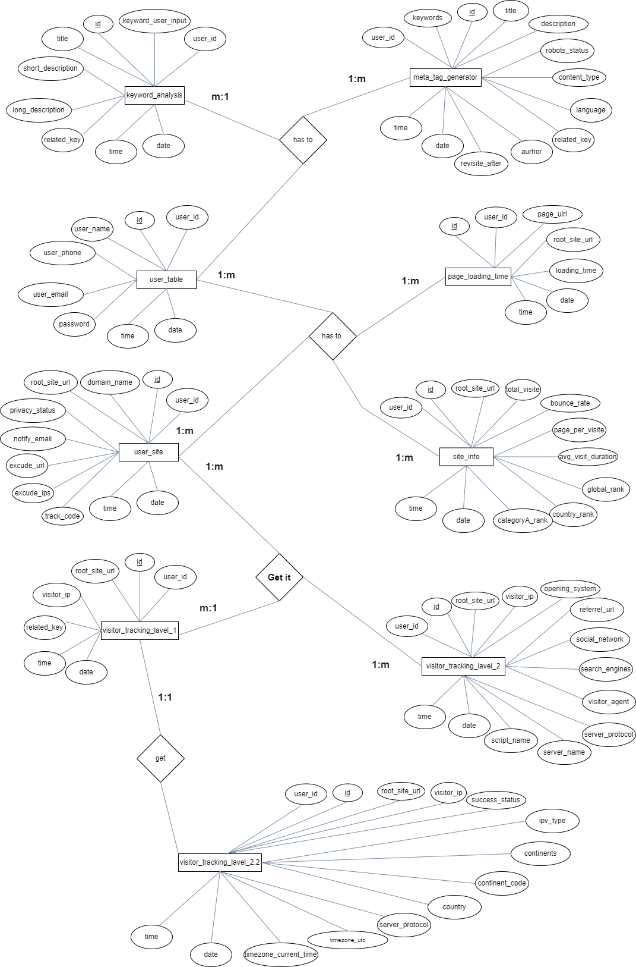

Fig:3.6.4 E-R Diagram

### 3.6.5 The Class Diagram

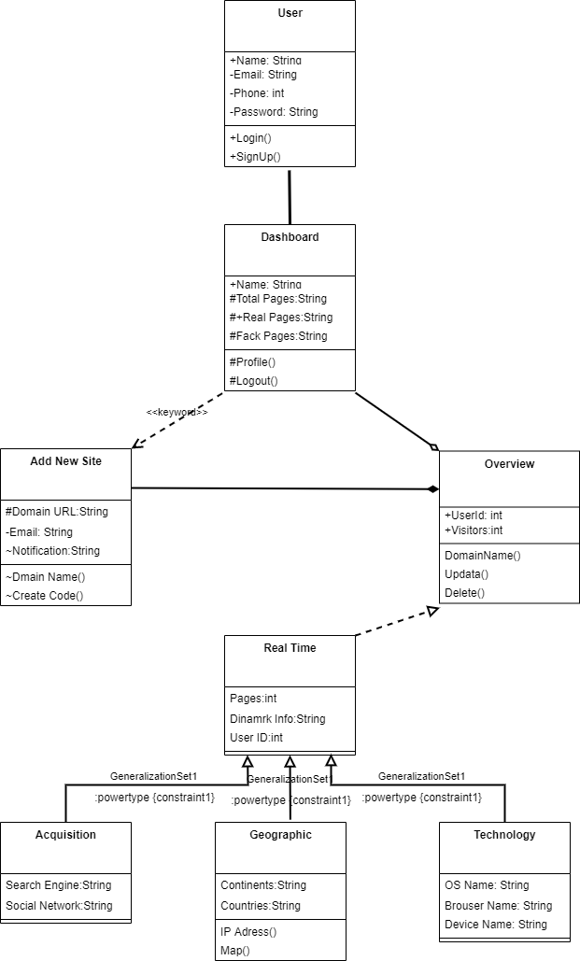

Fig:3.6.5 Class Diagram

## Software & Hardware used in the project

### 3.7.1 Technology used

|  |  |
| --- | --- |
| **Particular** | **The Technologies That Can Be Used** |
| Programming Language | PHP 7.2 + |
| Frame Work | Laravel or Node JS |
| Designing | HTML5, CSS3, Bootstrap4, React JS |
| Others Scripting | JavaScript, jQuery |
| Database | MySQL or MongoDB |
| API Development | Laravel Lumen, Google Auth API, Others |

### 3.7.2 Software Used

* PHP Storm
* Web Storm
* Visual Studio Code
* Postman
* Laragon
* Adobe XD

## Overview of programming instruction

This product is mainly developed by combining dependencies of PHP, Laravel and NodeJS also. JavaScript plays the biggest role here; without JavaScript our project would never have been possible to complete. Laravel, a popular framework for PHP, is used as the backend. PHP Storm and Web Storm are very useful development tools for professionals. PHPStorm is used to write PHP and Laravel code, and WebStorm is used to write JavaScript and REST API code. Visual Studio Code is a development tool that has been used as a helping hand in many ways. Postman is a very powerful testing tool for API testing. Laragon is used as the local server. MySQL is used as the database. All in all, with the help of these development tools and programming languages, we succeeded in completing our dream project.

# CHAPTER 4

RESULTS AND DISCUSSION

## 4.1 Testing Implementation

Testing implementation is process of testing upcoming implementation of a system, where tester or system architect will see cases and specification, is it implementable or have limitations.

|  |  |  |  |  |
| --- | --- | --- | --- | --- |
| **Test Case** | **Test Input** | **Expected Outcome** | **Obtained Outcome** | **Pass/**  **fail** |
| 1.Registration | Empty name,  email, mobile number, district, password, confirm password | Show restriction to  Fill all the fields | Fields must be filled by data. | Pass |
| 2. Login | Login email and,  password | Successfully login | Successfully login | Pass |
| 3. Password | Incorrect password or empty field | Warning the incorrect password or field is empty | Show warning | Pass |
| 4. Profile settings | View profile, Update profile | Show and update profile information | Show and update information successfully | Pass |
| 5. Add Site | Add site, update site. | Successfully add site, and update site. | Successfully add site, and update site. | Pass |
| 6. Visitor Tracking | Visitor User agent | Successfully Track. | Successfully Visitor User Agent Track. | Pass |
| 7. Keyword Generator | Single or Multi-word | Successfully Generate Keyword | Successfully get a targeting keyword. | Pass |
| 8. Meta Tag Generator | Site Title, Site name, short description, Site Keywords. | Meta Tag Generate with information. | Successfully Meta Tag Code Generate. | Pass |

## 4.2 Questions for some users:

1. UI was user friendly?
2. Do you think you found the two or more information you needed as expected?
3. Do you think current system was easier than other system?

**Answer:**

|  |  |  |  |
| --- | --- | --- | --- |
| **User** | **Question 1** | **Question 2** | **Question 3** |
| 1 | Yes | Yes | Yes |
| 2 | No | Yes | Yes |
| 3 | Yes | Yes | Yes |
| 4 | Yes | No | Yes |
| 5 | Yes | Yes | No |
| 6 | No | No | Yes |
| 7 | Yes | Yes | No |
| 8 | No | No | Yes |

## 4.3 Implemented Result

There are mainly two objective results, like Keyword Analyzer and Web Analyzer. There is another type of event on the keyword generator. Which is called a meta tag. Keyword actually finds the target word with a Description. Which can be used in meta tags. And if a user logs in on the web ‍analyzer, a dashboard will be created in his name. Through this, he can know the detailed information of his site. Which is described in detail below.

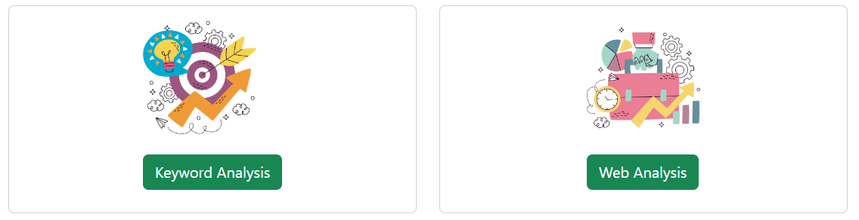

Fig: 4.1 Implement two features

### 4.3.1 Web Analyze Result

First of all, when any user had visited our project for login it should be signup. And when login then create a user dashboard. If not signed up then he must sign up first.

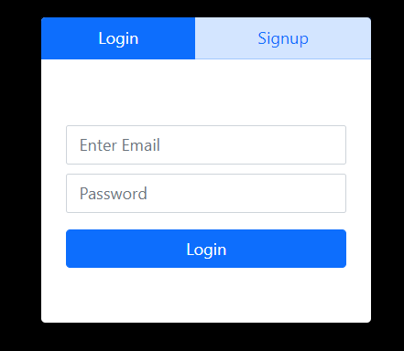

Fig:4.1.1 Signup and Login.

When a user login with valid information then he will be a valid user. Also, get a dashboard. There are we can see several types of visitors, like total visitor, real visitor and fake visitor. Actually, total visitor means how many people visited and search in your website. In a real visitor for the valid visitor. For example, when a user visit in his/her won device and valid IP. On the other hand, we can see the fake visitor. Fake visitor means they are illegal, invalid, unauthorize.

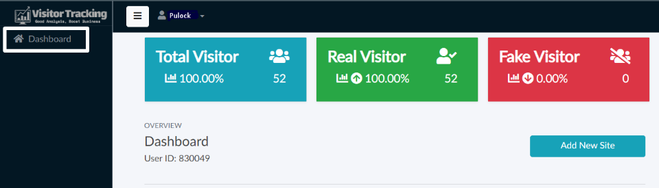

Fig: 4.1.2 Dashboard

A unique user ID is created on the dashboard from our system. In the beginning, three cards show the user panel feck visitor, total visitor, and rail visitor, and add a new site link. There are real visitors only who will use IP addresses and have specific verified users and fake users as we can see from localhost, we are in test purposes.

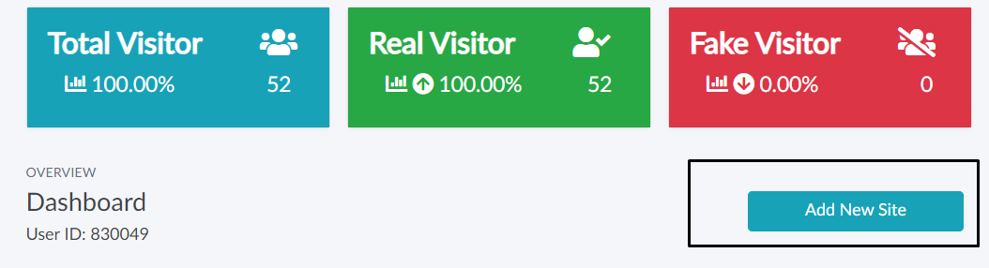

Fig: 4.1.3 Types of Visitors and Add a new site.

When any user in Add New Site clicks a button then he gets a new window. For a input field domain URL put in this field. When a user takes own URL then create a domain name.

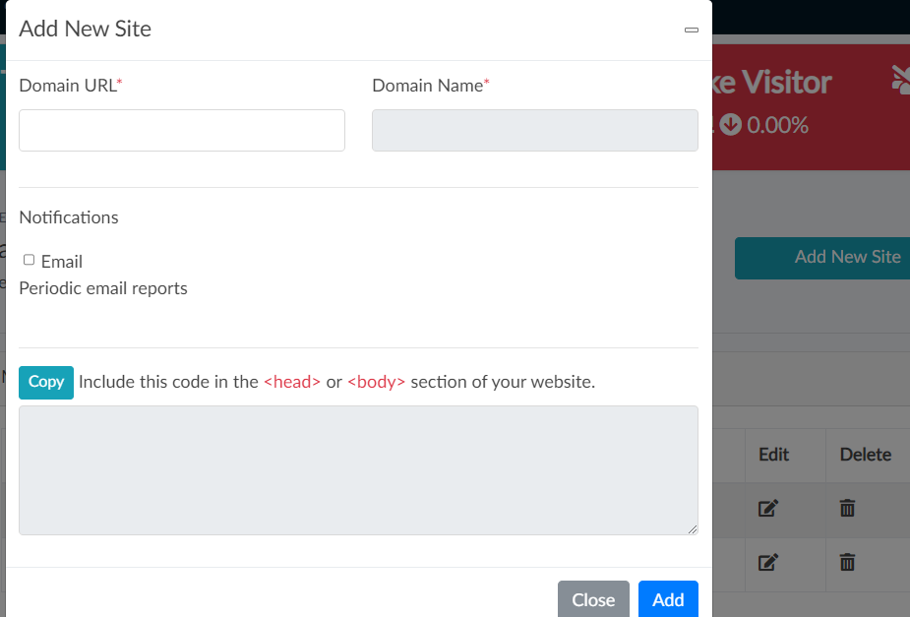

Fig: 4.1.4 Add a new Site

When user click on site then generate a scripting tag. This scripting tag is mainly work when put on user’s code of index page. Then actually system provide all information. So this procedure is first step for this any users.

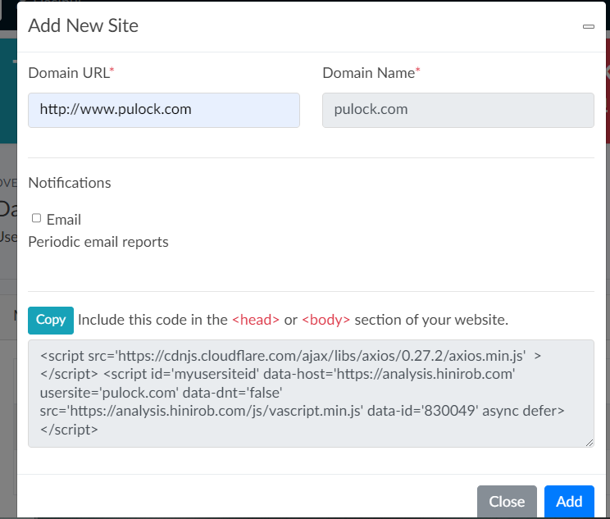

Fig: 4.1.5 Generate tracking scripts

When add a new site then get a details like visitor edit delete. A user creates a domain more than one domain URL. Serially show this own domain and also click specific domain URL.

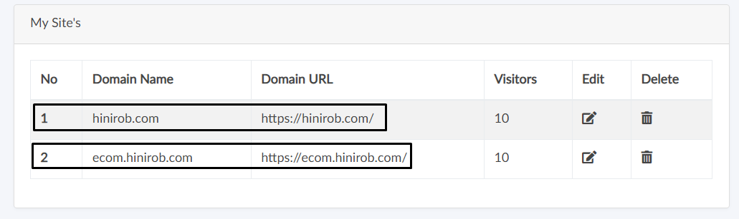

Fig: 4.1.6 Site Details

In this fig:4.1.6 have a six attribute, like Realtime, Overview, Behavior, Acquisitions, Geographic, Technology. For a include subfunction in this method.

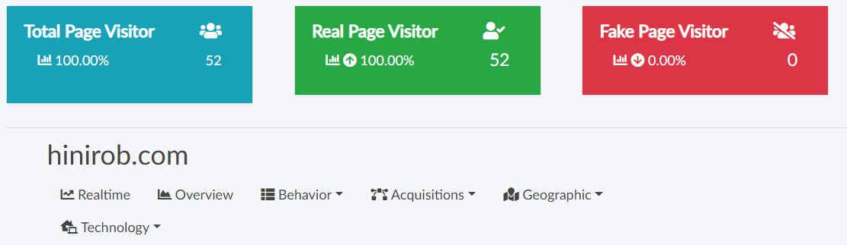

Fig: 4.1.7 Type of Page Visitor

First of all, when a Realtime and Overview hit that in this page information details overall and Realtime. For the behavior there have pages and landing pages. Acquisitions function more than many subfunction, like Referrers, Search Engines, Social Networks. When hit the Geographic button it has Overview Geographic, Continents, Countries, View Visitor IP On Map. Any user can information getter how technology use in this page, like Overview Technology, Operating System, Browsers, Devices.

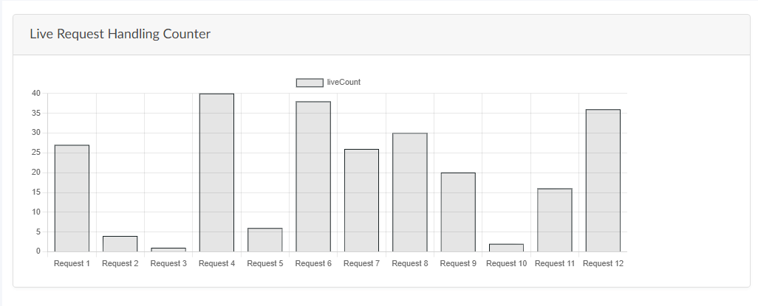

Fig: 4.1.8 Live Request Handling Counter Statistics

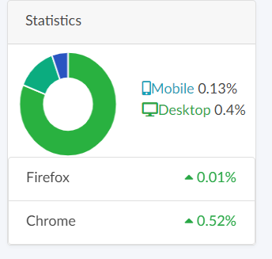

Fig: 4.1.9 Devices and OS Statistics.

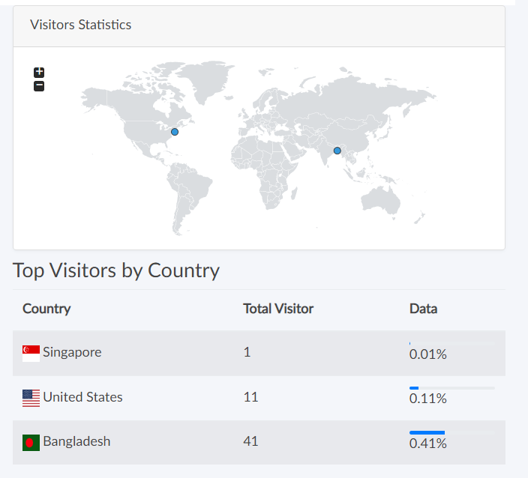Fig: 4.1.10 Top Visitors by Country.

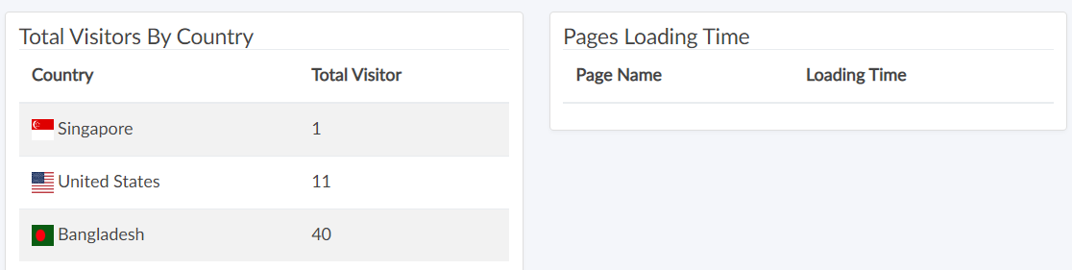

Fig: 4.1.11 Country base Total visitor.

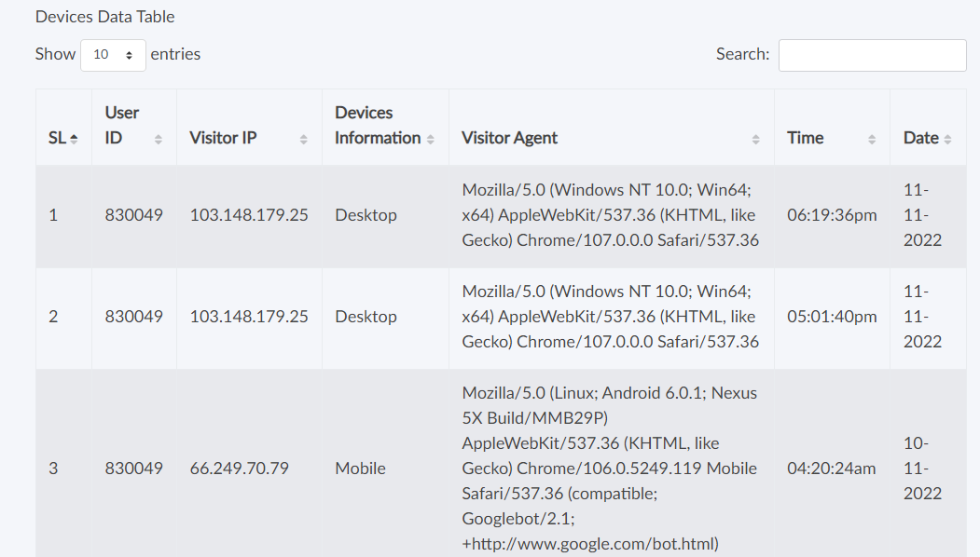

Fig: 4.1.12 Kind of Devices.

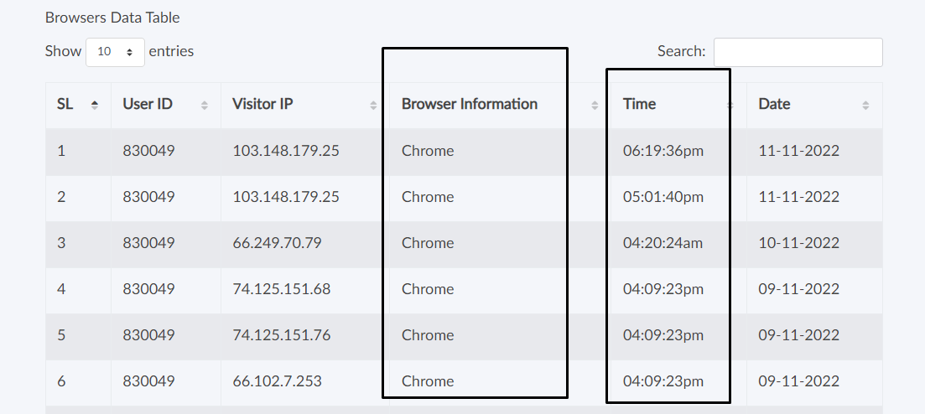

Fig: 4.1.13 Type of Browser.

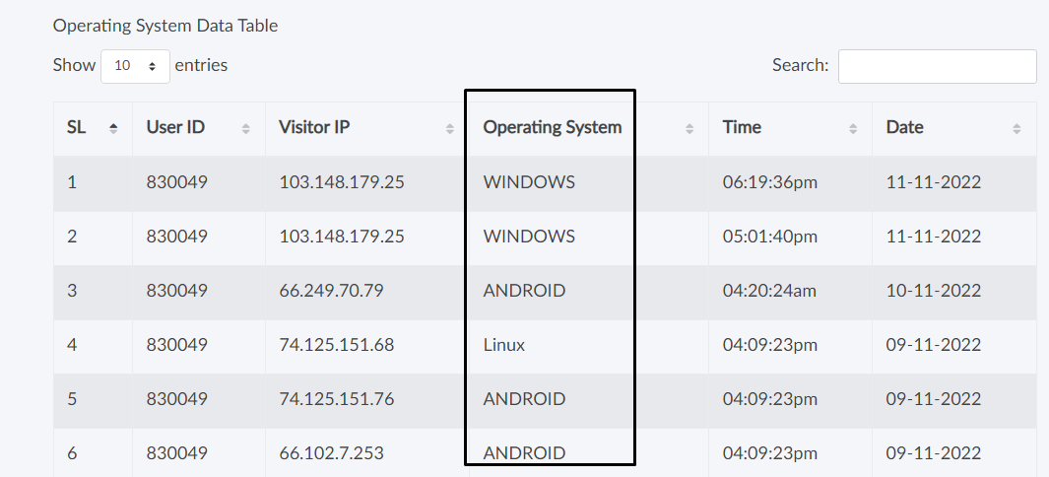

Fig: 4.1.14 Type of Operating System.

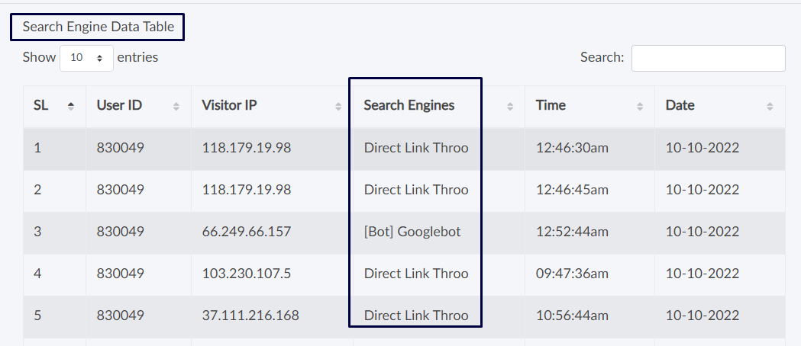

Fig: 4.1.15 Type of Search Engines.

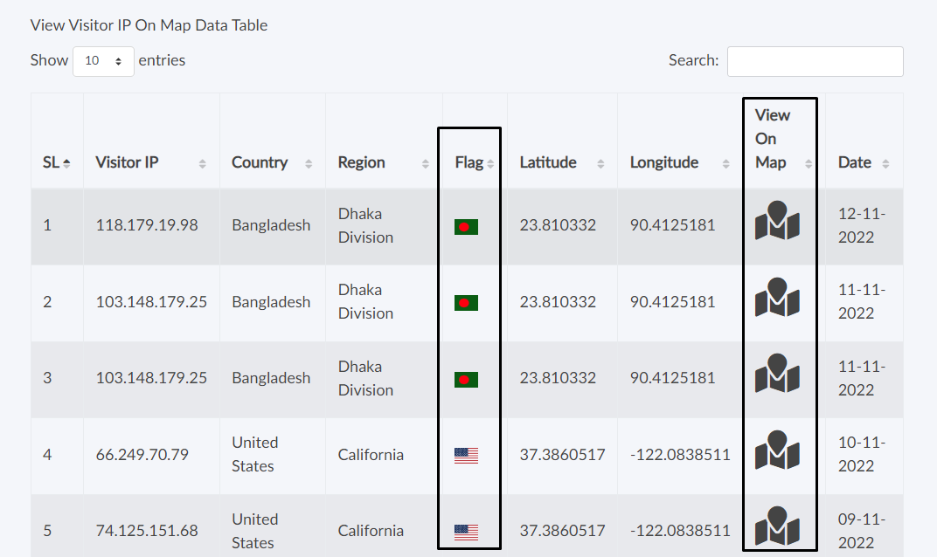

Fig: 4.1.16 Country Detected.

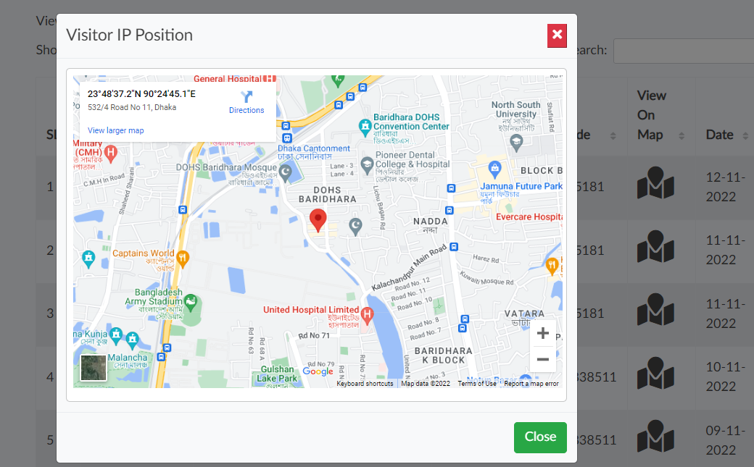

Fig: 4.1.17 Visitor IP Position 1.

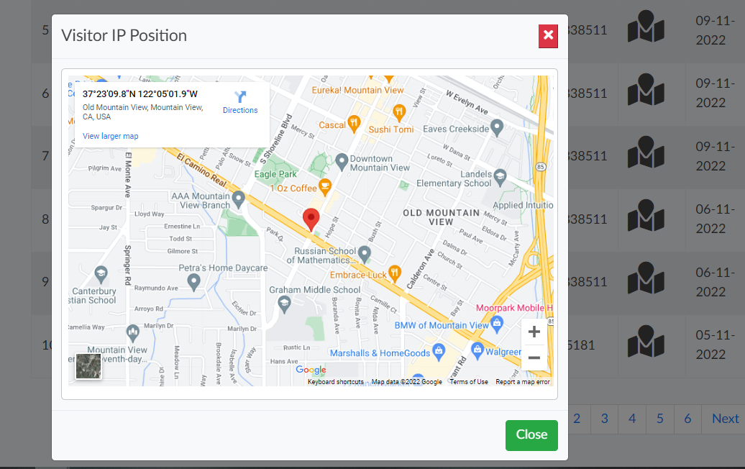

Fig: 4.1.18 Visitor IP Position 2.

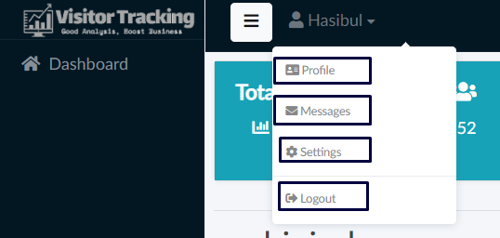

Fig: 4.1.19 User menu.

### 4.3.2 Keyword Analyze Result

A keyword is a word or a short phrase that describes the content of the web page. That is, a keyword is a search query (Search Query) or its specific words or short phrases based on which search engines display websites in SERPs.

The help of various search engines like Google or Yahoo has to be taken to collect the data. Entering these search-engines and typing the information we are looking for or what we want to know in the search bar, page after page of sites related to that information come in front of us. To get any information or data, what we write and search in the search engine is the keyword. To find any information or information, visitors use Google, Yahoo or any other search engine to find out which keywords are used the most and to research other competing sites on that keyword more or less with them. Keyword research is called keyword research.

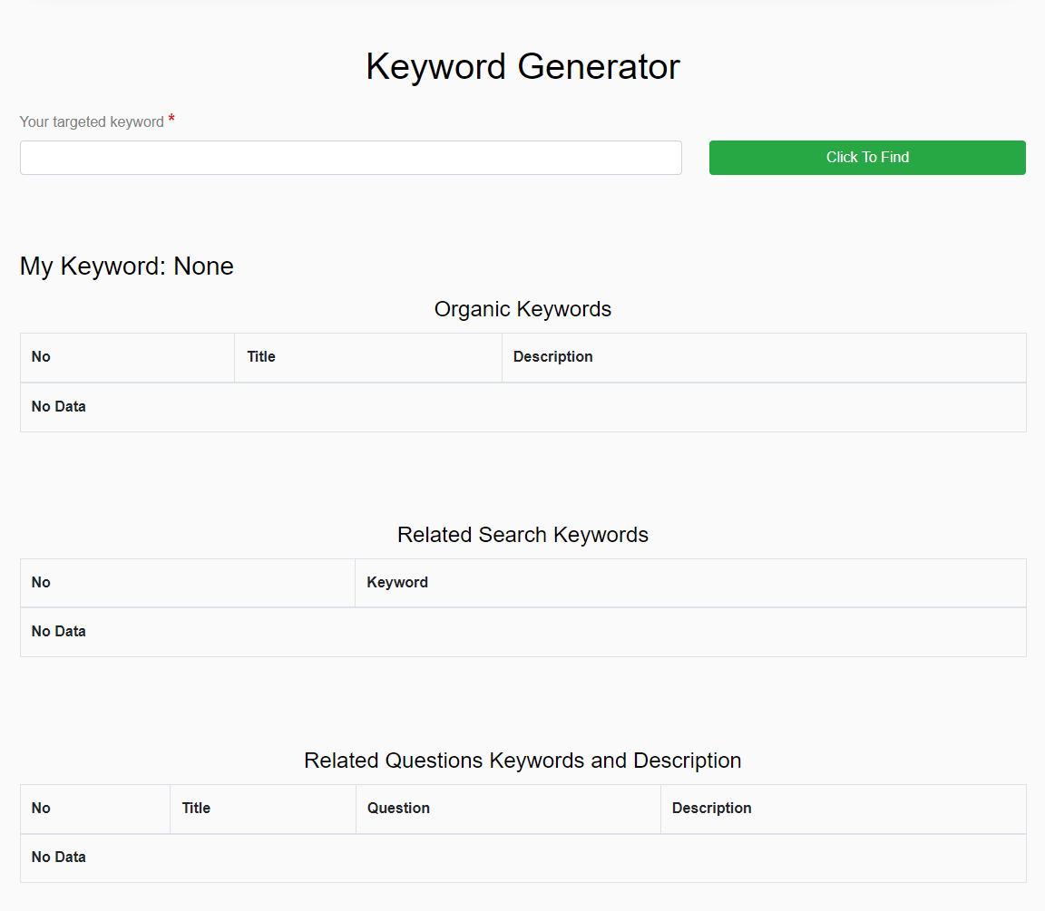

Fig:4.2.1 Keyword Generator

You want to write a topical content or blog. Topics—'What is a Logo', 'How to Create a Logo', 'How to Register a Logo' etc. I have said before that if you want to write a blog or content based on the subject, you cannot write whatever you want according to your whims. Why can't you? Because if you write as you like, then when the visitors search, your site or the topic you have written will not appear in front of them. Now if someone goes to the search engines to find out about the logo, how will the search engines like Google identify your content or blog? It's simple—you need to write SEO-friendly keyword-based content. The keywords that are usually searched for the logo should be targeted and written.

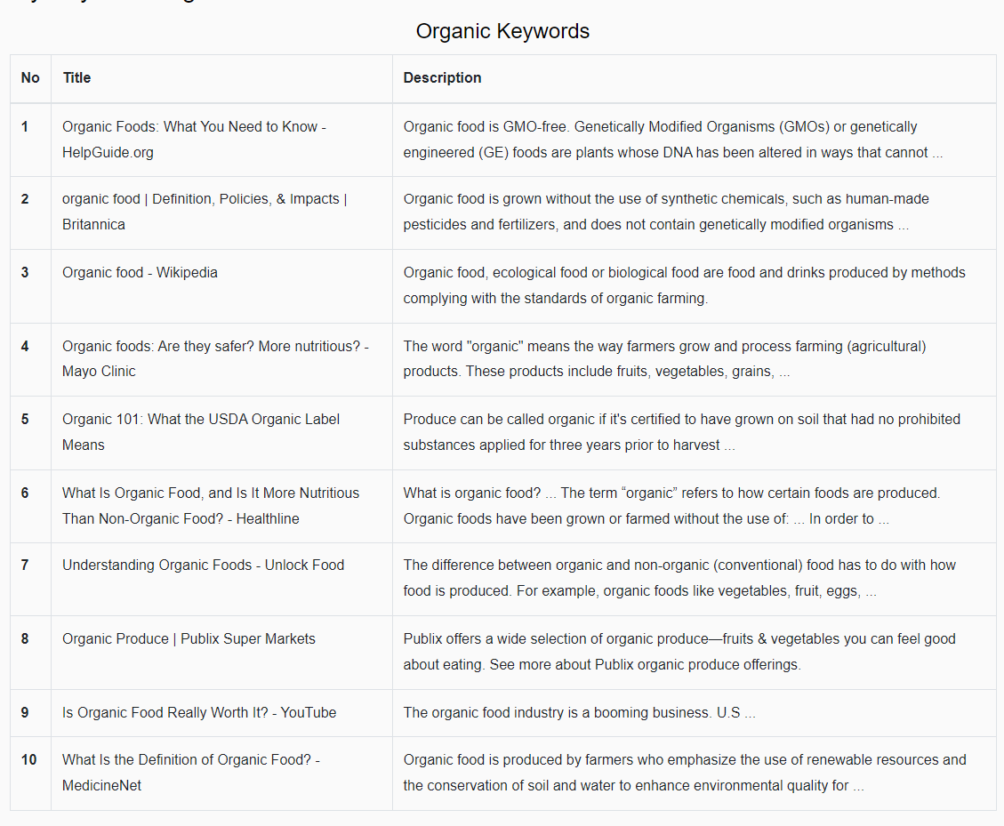

Fig:4.2.2 Organic Keyword

Many of us have more or less idea about the kind of changes that have come in the last decade in the field of search engine optimization (Search Engine Optimization). In this, the level of competition in the market has increased significantly compared to before. Proper keyword research is necessary to survive in this storm of search engine optimization. If there are mistakes in keyword research then your site will not rank in Google search. Therefore, if you can use that information by doing keyword research correctly, you will get the right rank in Google search. Google, Yahoo or other search engines have their own algorithms. There is also a change in that algorithm. Matching this algorithm is not the only rank that can be obtained. Also important is how consistent the content you write is. Also, using keywords that are being searched for more often will not get you to the top of search engines. If you pay attention to the keywords that are searched more often as well as the keywords that are searched less in the same topic, then it gets a different priority in the search engines. And keyword research is needed to confirm these issues. So, you can understand why keyword research is so important.

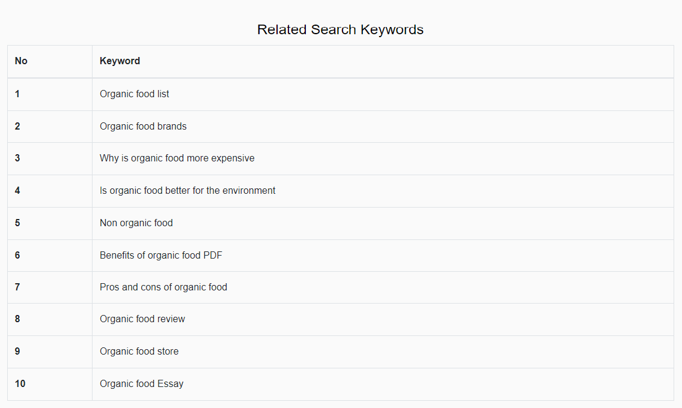

Fig:4.2.3 Related Keywords

There is no denying the role of related keywords in keyword research. When searching for a specific topic, the words that people use or write about that topic are related keywords. If it is difficult to find the right keywords, then using related keywords can also increase the ranking of the content. So, during keyword research, related keywords should also be found.

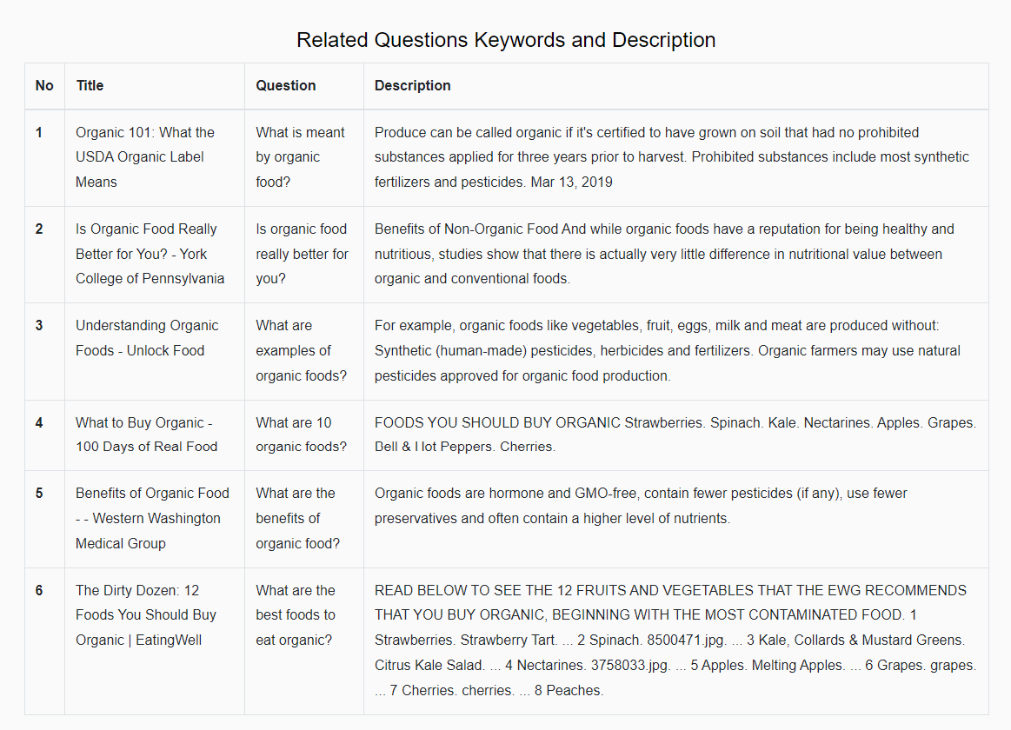

Fig:4.2.4 Related Keywords and Description.

Also pay attention to long tail keywords during keyword research. Find long tail keywords. In this case, be careful if the specific keyword is correct. Because in many cases while writing long tail keywords, it is seen to deviate from the topic.

### 4.3.3 Meta Tag Generator

Meta Tag or, Meta Tag is an important thing for search engines. When the search engine comes to your web site or scrolls, it gets important information from your web site through the meta tag that helps your site rank in the search engine.

With the help of meta tags, search engines can simultaneously know about the visitor's website or blog. Everyone wants more visitors to their website, because more visitors mean more income. We all want visitors to come from search engines like Google. If you don't tell Google what the website is about, how will Google send visitors to the website? With the help of meta tags, other search engines including Google will know about the website.

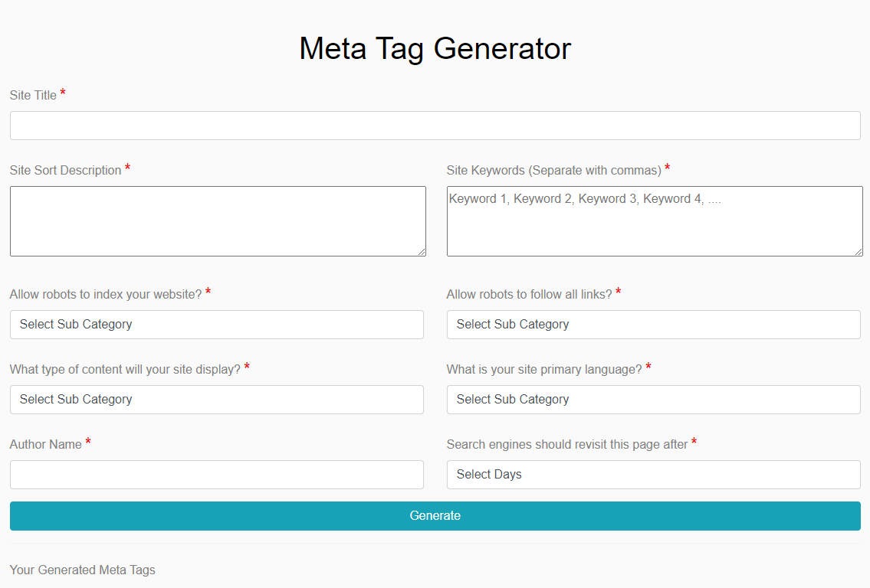

Fig:4.3.1 Meta Tag Generator1

On page SEO is very important for getting visitors from search engines. And a big part of this on page SEO is Meta Tag. If you want to bring visitors from search engines to your site, you must use Meta Tag. This will make your blog or site search engine friendly. And for using meta tags, there is no better Html tag than Meta Description & Meta Keyword. (I think others may have different opinions.) These tags tell search engines what your site or content is about. And these tags help your site/blog to be indexed properly. Although meta tags appear in blog posts, they are more important to search engines

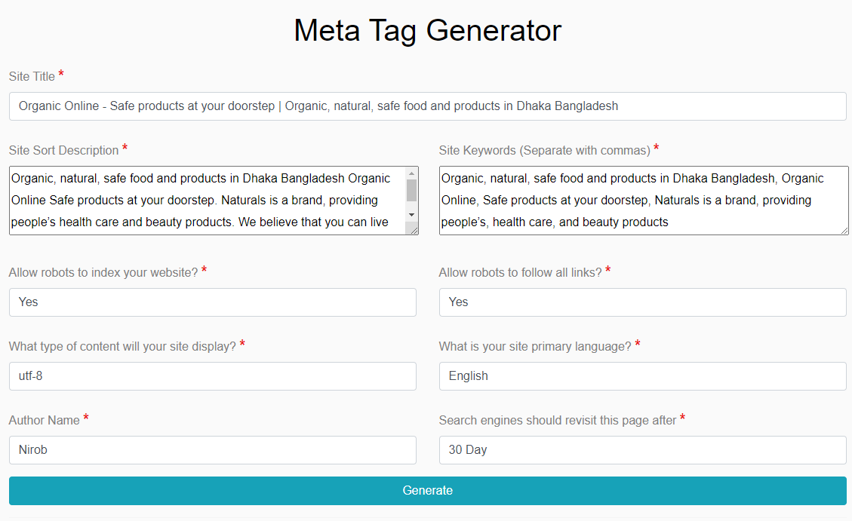

Fig:4.3.2 Meta Tag Generator2

Meta Description: You can use this tag in maximum 160 words for your blog or site. It should not be used in excess.

Meta Keywords: This tag is most important. Through this, visitors come to your blog / site from search engines. Most of the site's admin / blogger use dozens of keywords. If you use too many keywords, the search engine will leave you behind. So, use some good keyword according to your blog / site quality. It will get good results. If you want, you can search on Google.

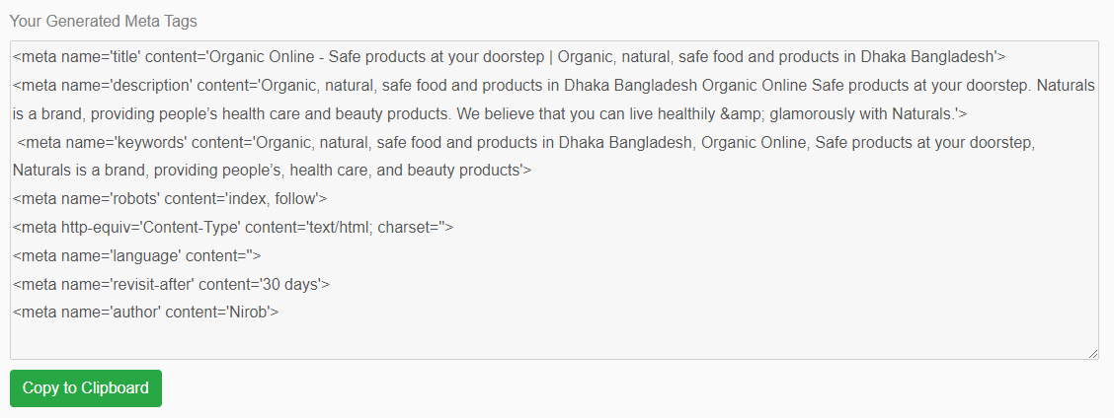

Fig:4.3.3 Meta Tag Result

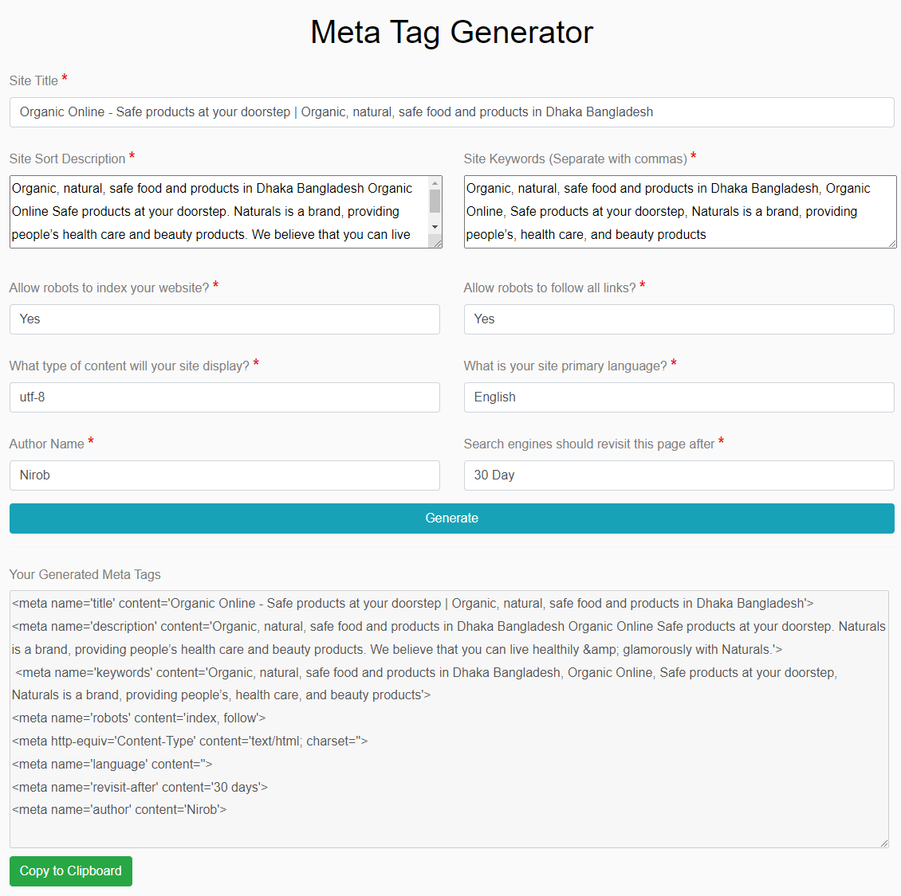

Fig:4.3.4 Keyword Generator

Meta Author: This tag is not very important. But many people want his name or site name to be in meta-author. So, they use it. Using this does not harm your site/blog but gets very well known to the search engines.

Meta Robot: Sometimes you want search engine robots to avoid indexing some of your content. Then No-Follow and Do-Follow are used in its tags. If you do not understand this tag, please refrain from using this tag. If you use this tag incorrectly, you can lose all visitors to your blog/site from search engines. I will try to discuss this in detail later on.

## 4.4 Discussion

We are very happy to have completed this project successfully. Currently, the demand for all these automation software is increasing day by day. I hope this will serve as a milestone for users in the future. The purpose of doing this is to develop it specifically for users who cannot analyze their site.

Start the project well with a completely clear idea. Requirements analysis is done very well, and the software architect designs accordingly. In the beginning everything was going well, problems were encountered when the project implementation work started. Couldn't find any resources on how to collect visitor data for a user's site. A lot of research has been done, a lot of studies have been done, but we still couldn't find the resources we wanted.

Special thanks to our project supervisor sir, without him we would not have been able to complete the project so well in such a short time. When we were facing any complex problem, our supervisor sir gave us various information, which we were able to solve our complex problems very easily.

# CHAPTER 5

CONCLUSION

## 5.1 Conclusion

Using our website analysis system, users can register with us here and then provide the URL of their website, and we will create a code on their entire site based on the address of the URL. When you update your site's index tag, it will be activated in our system, which shows the user an overview of the site where he can learn how much time he has spent online and what percentage of men and women are on the site. We can give him good advice on how he can improve his website if he wants and he can find the right competitor for this competition.

## 5.2 Scope of Improvement

Artificial intelligence or artificial intelligence is on everybody's lips nowadays. One of the marvels of technology is artificial intelligence, which is going to become an integral part of our lives in the coming days. Developed world countries are already conducting extensive research on artificial intelligence. It has started to be used in vehicles, food preparation or industry.

E-commerce giants Amazon or Alibaba are moving forward relying on artificial intelligence in these areas. Their artificially intelligent website is built to collect tons of data and analyze it on its own. Where so much information is not possible to analyze accurately even by employing numerous people.

In a competitive market, the aim of the companies is to deliver the best quality service to the customer while saving time and cost. Hence the use of artificial intelligence in digital marketing has come as a boon.

So, our project has scope to use artificial intelligence in terms of visitor analysis. Keyword analysis is no exception, in this case we can implement natural language processing of artificial intelligence. So that the keywords provided by us are more useful to users and their products can occupy more market.

# REFERENCES

|  |  |
| --- | --- |
| [1]: | T. Bujlow, V. Carela-Español, J. Solé-Pareta and P. Barlet-Ros, "A Survey on Web Tracking: Mechanisms, Implications, and Defenses," in Proceedings of the IEEE, vol. 105, no. 8, pp. 1476-1510, Aug. 2017, doi: 10.1109/JPROC.2016.2637878. |
| [2]: | A. Salini, I. Malavolta and F. Rossi, "Leveraging Web Analytics for Automatically Generating Mobile Navigation Models," 2016 IEEE International Conference on Mobile Services (MS), 2016, pp. 103-110, doi: 10.1109/MobServ.2016.25. |
| [3]: | Leitner, P., Maier, K., Ebner, M. (2020). Web Analytics as Extension for a Learning Analytics Dashboard of a Massive Open Online Platform. In: Ifenthaler, D., Gibson, D. (eds) Adoption of Data Analytics in Higher Education Learning and Teaching. Advances in Analytics for Learning and Teaching. Springer, Cham. |
| [4]: | Growthbadger  https://growthbadger.com/blog-stats/ |
| [5]: | Markinblog  https://www.markinblog.com/how-many-ecommerce-sites/?gclid=CjwKCAjwi8iXBhBeEiwAKbUofbs8iio2GcGhQjAoMn2SYLbZYaCS0huOLQt-G5shsi490rnq4GXXQBoCJiYQAvD_BwE |
| [6]: | Hotjar  https://www.hotjar.com/about-us/ |
| [7]: | Similarweb  https://www.similarweb.com/ |
| [8]: | Semrush  https://www.semrush.com/ |
| [9]: | chartbeat  https://chartbeat.com/ |
| [10]: | ahrefs  https://ahrefs.com/ |
| [11]: | statcounter  https://statcounter.com/ |
| [12]: | openwebanalytics  https://www.openwebanalytics.com/ |
| [13]: | Google analytics  https://analytics.google.com/analytics |
| [14]: | Hackernoon  https://hackernoon.com/ |
| [15]: | Serpapi  https://serpapi.com/ |
| [16]: | Keywordseverywhere  https://keywordseverywhere.com/ |
| [17]: | Laravel  https://laravel.com/ |
| [18]: | Reactjs  https://reactjs.org/ |
| [19]: | Ssitbari  https://www.ssitbari.com |
| [20]: | Webangla  https://www.webangla.com/keyword-bangla/ |
| [21]: | Suluksandhan  https://suluksandhan.com/ |
| [22]: | Banglahub  https://banglahub.com.bd/keyword-research-method/ |
| [23]: | Shoptips24  https://shoptips24.com/seo-tips/3247/ |
| [24]: | Jit  https://jit.com.bd/what-is-keyword-research/ |
| [25]: | Artificial Intelligence in Digital Marketing  https://digitalmarketinginstitute.com/blog/some-inspiring-uses-of-ai-in-digital-marketing |